# Final Report

## **Overview:**

The main idea of this assignment was to create a weather forecast application using OpenWeather API. The API is used to get the weather data in XML format. The application shows the weather data for the current day, tomorrow’s data and also for the next 5 days data at 3 hours interval.

## **Requirements:**

The application requires its own generated API key from OpenWeather in order to make AJAX requests. The response data which is in XML format needs to be parsed and displayed on the website.

## **Features:**

* Current Time, Day and Date
* Current Weather forecast with icons
* Changing background Image of the home page according current weather using OpenWeather icon URL
* Tomorrow’s weather forecast with icons at 3 hours interval in scroll bar
* 5 days weather forecast of high and low temperature with icons
* Toggle Metrics
* Real Time two Charts (Line chart & Bar Chart)
* Comparing weather Forecast of two cities

## **Challenges:**

* Parsing the XML data.
* Creating the navigation.
* Hiding and collapsing the card to show 5 days and current data on the same card.
* Designing the compare page.
* Designing Charts
* Using grids to set the 5 days temperature in a div and align it.

# **Working:**

**Weather Forecast:**

The API is called via AJAX( Asynchronous JavaScript and XML). With AJAX, web applications can send and retrieve data from a server asynchronously without interfering with the display and behavior of the existing page.

Two API calls are made for current day and 5 day forecast data. The response data which is in XML format, is stored in an array to minimize parsing it again and again when displaying it multiple times.

Code snippet for parsing data from XML are:

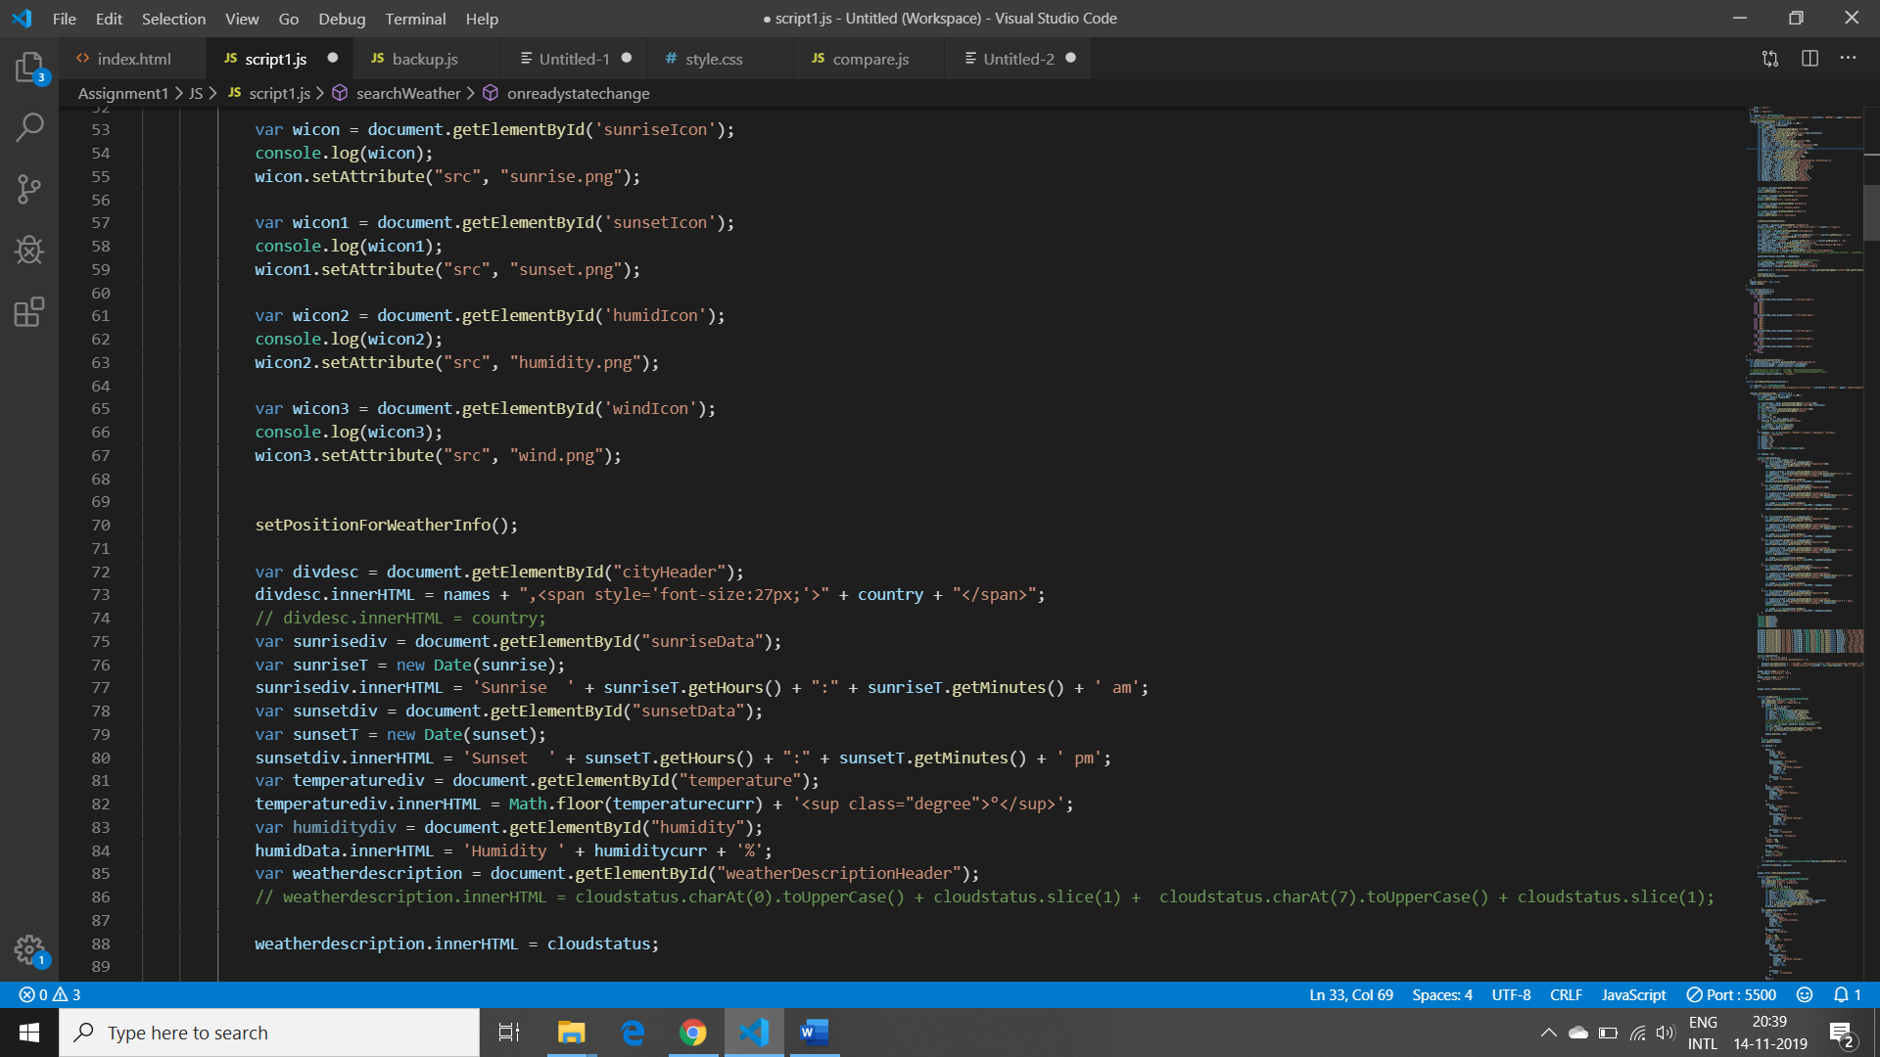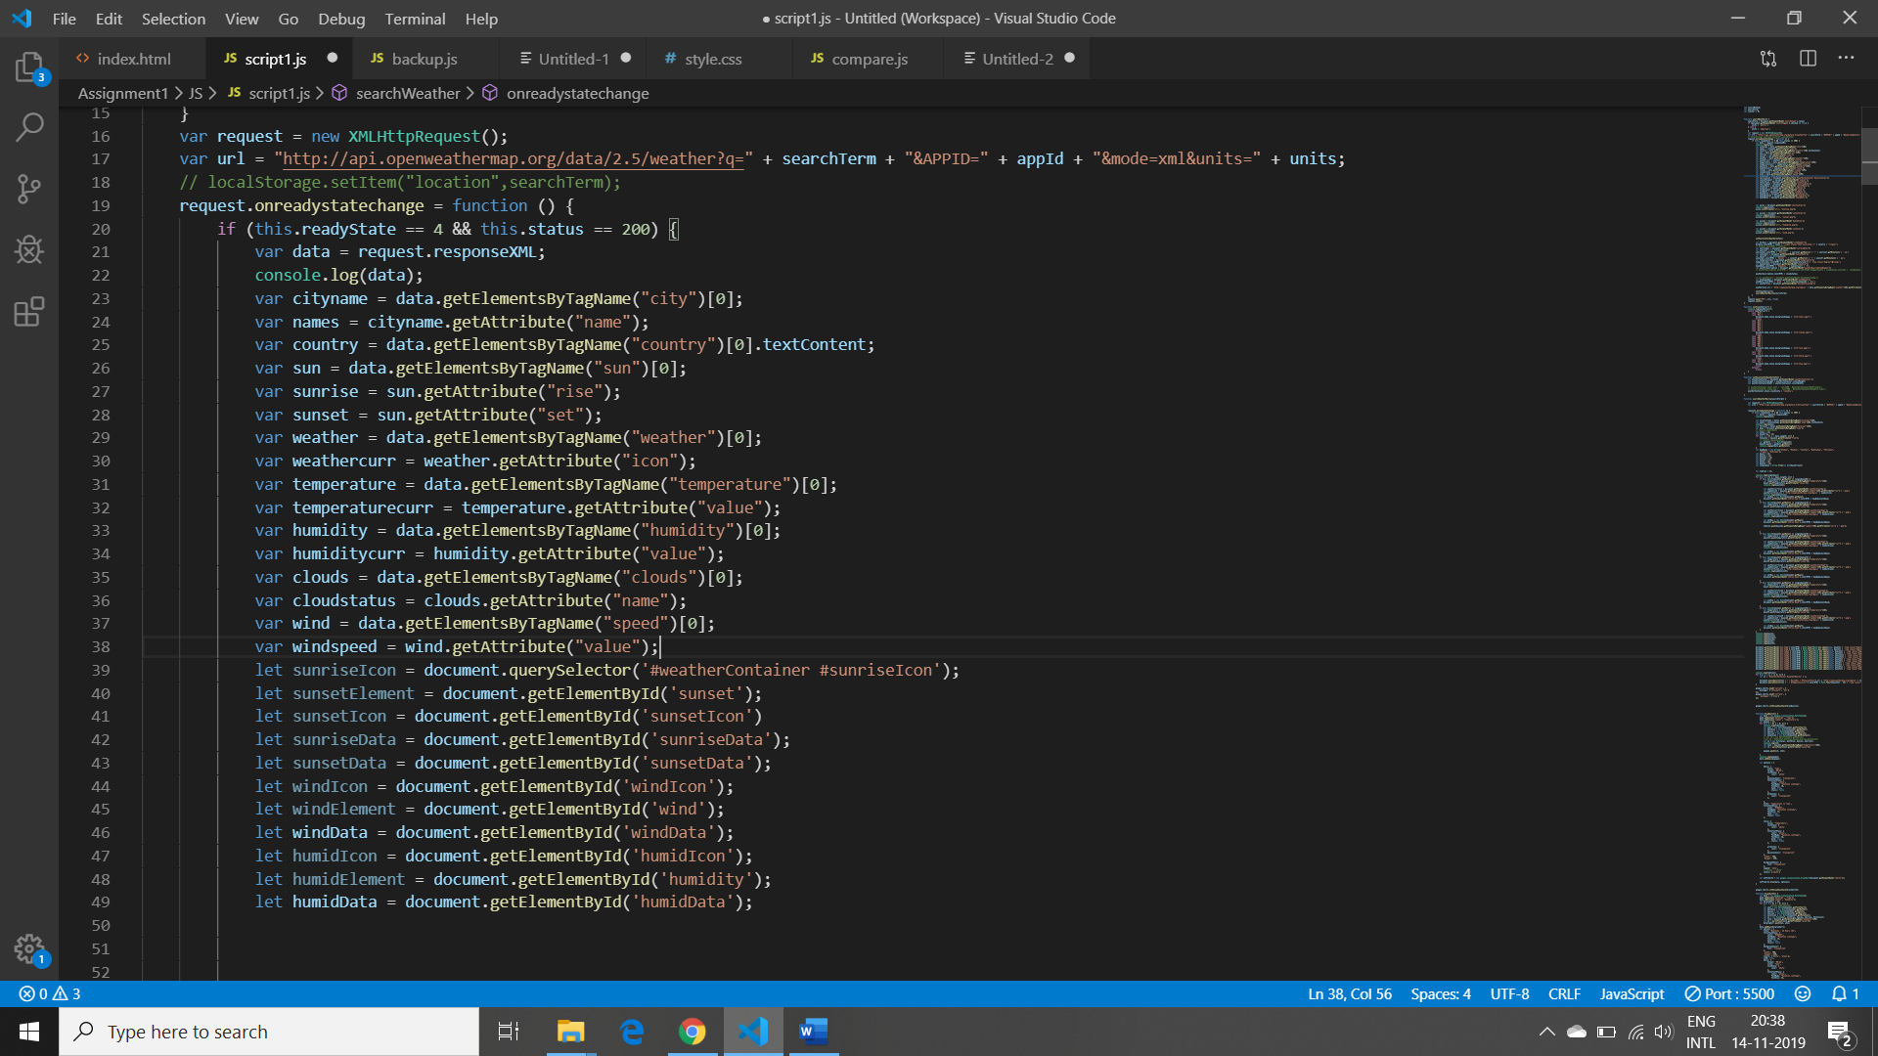

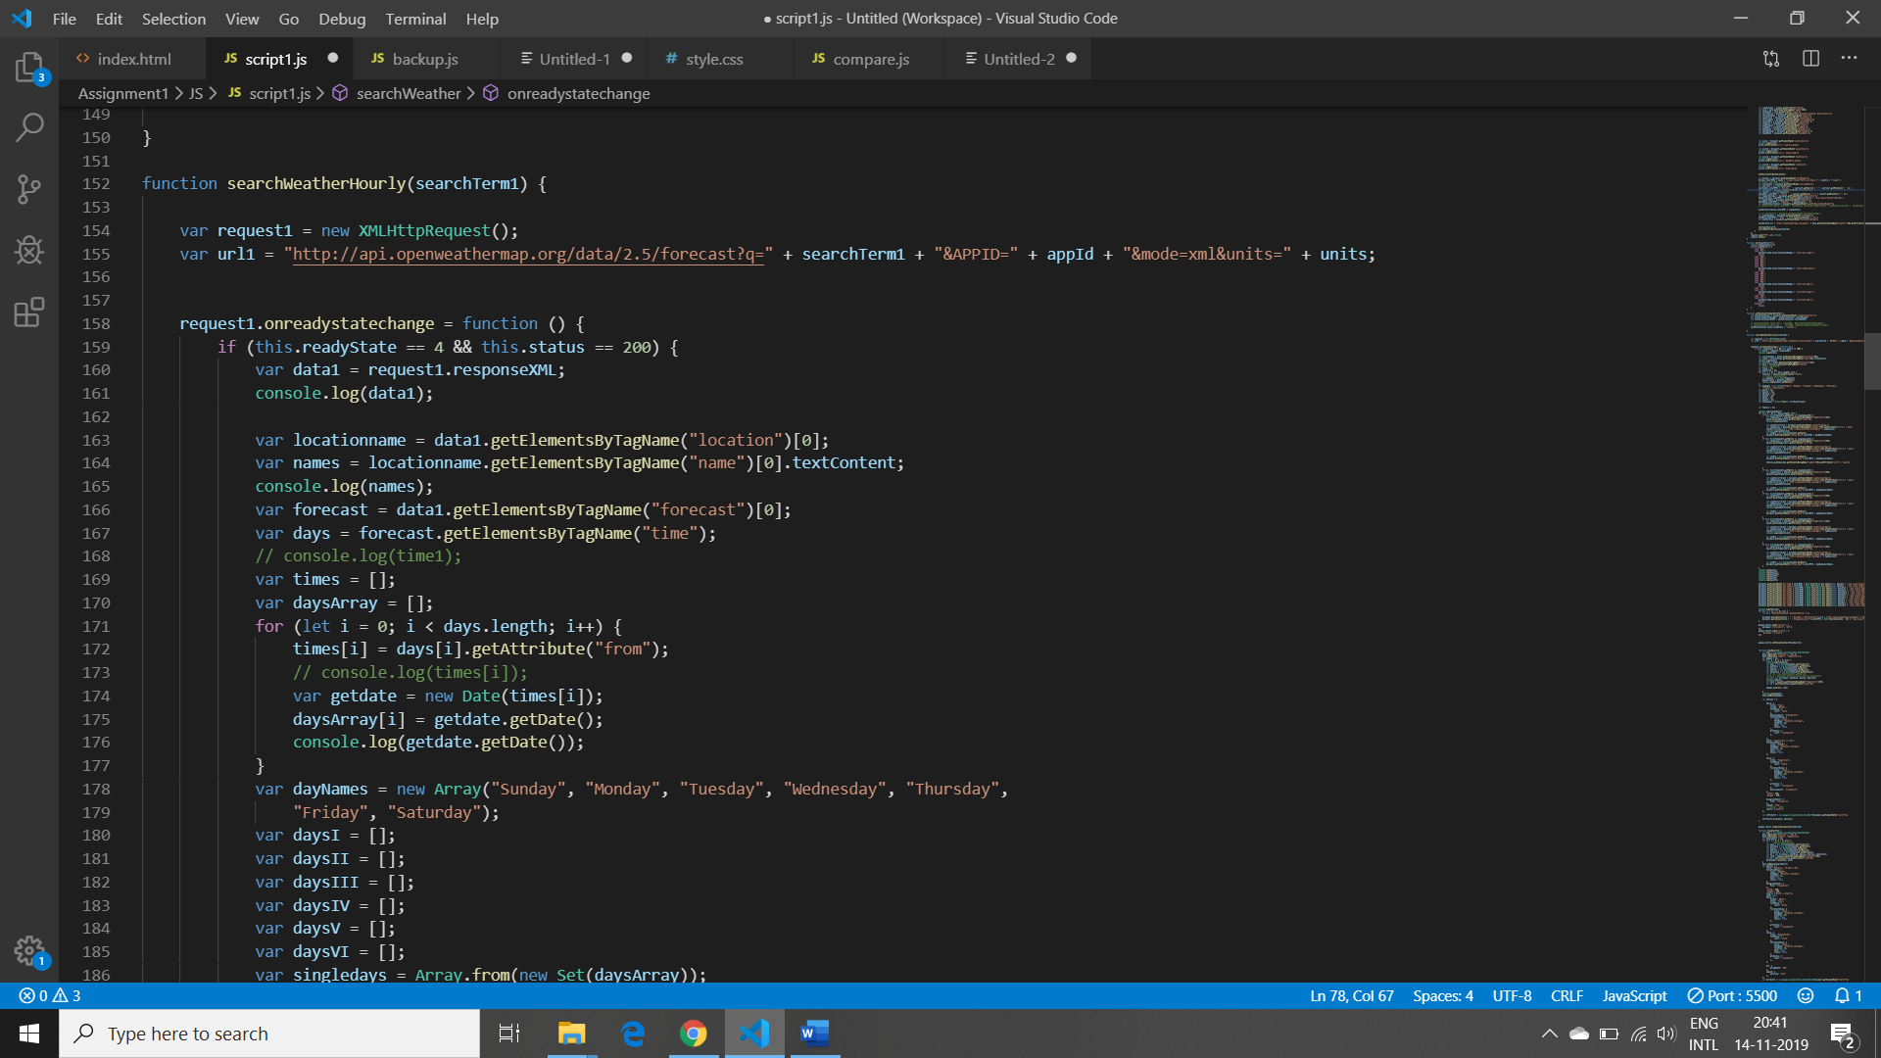

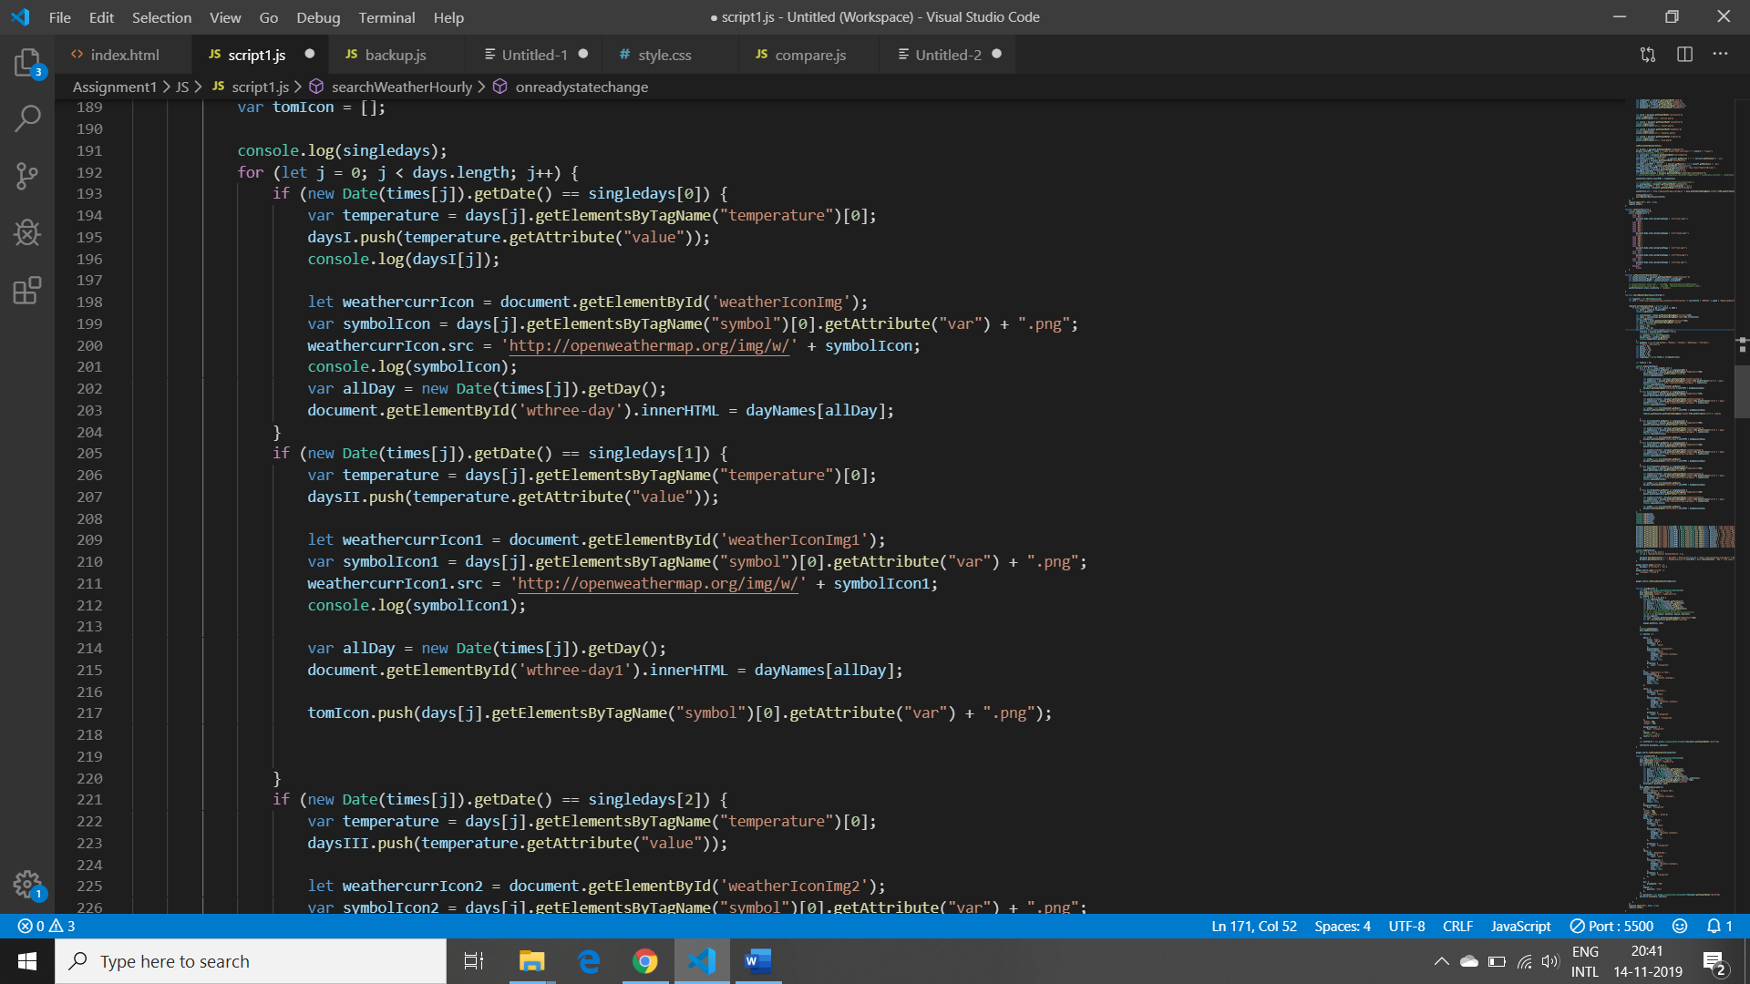 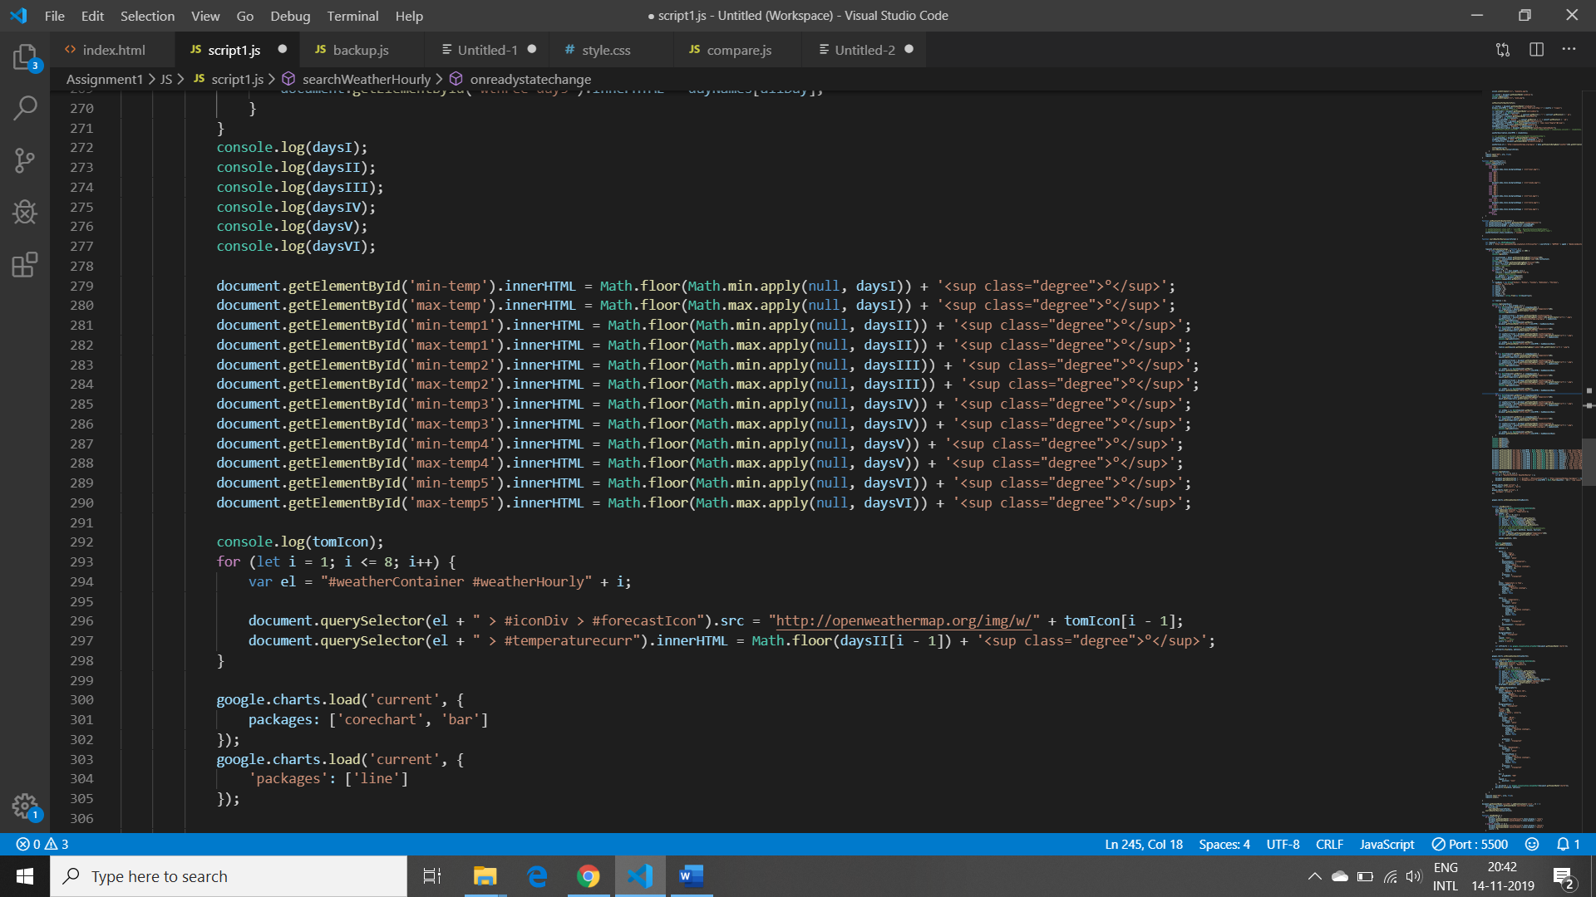

Here, I have used two functions to parse the data from XML and then set the data into the cards. First function is used to get the current data forecast using API key and in DOM scripting. I’m parsing City name using getElementByTagName(“city”) with child node 0 and then settting the the name using getattribute. Similarly, I’m parsing data of sunrise and sunset from sun and icon from weather.

In the second function, I’m parsing the 5 days data from XML.Firstly I’m parsing the time from forecast and then storing those time in the array . Then, making the array of 5 days and then extracting the data of one day from 40 data and then storing the data into single days data using for loop. Afterwards, setting the attribute in the web application using getAttribute.

Lastly , getting the min max value of each day from the dayArray.

 document.getElementById('min-temp').innerHTML = Math.floor(Math.min.apply(null, daysI))

document.getElementById('max-temp').innerHTML = Math.floor(Math.max.apply(null, daysI))

Cards are designed which shows 3 hours forecast for tomorrow’s weather and also it shows the high and low temperature of five days in the same card. The parsed data is set to the elements using DOM scripting.

Also, I’m showing the current time and date on the main page of the card.

function startTime() {

    var today = new Date();

    var h = today.getHours();

    var m = today.getMinutes();

    var s = today.getSeconds();

    m = checkTime(m);

    s = checkTime(s);

    document.querySelector('#weatherContainer #txt').innerHTML =

        h + ":" + m + ":" + s;

    document.querySelector('#weatherContainer1 #txt').innerHTML =

        h + ":" + m + ":" + s;

    document.querySelector('#weatherContainer2 #txt').innerHTML =

        h + ":" + m + ":" + s;

    var t = setTimeout(startTime, 500);

}

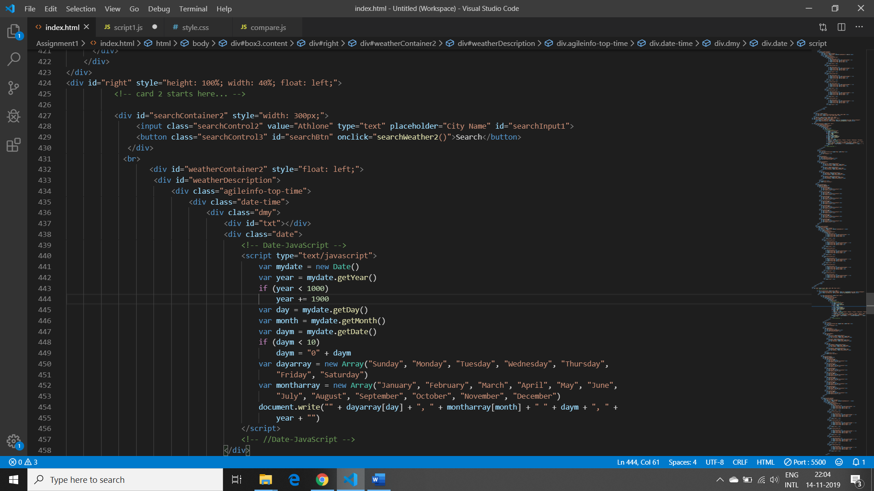

**Weather Charts:**

I have used google charts to show the charts in my application. As we know that,

Google chart tools are powerful, simple to use, and free. So, in my application used two charts one is line chart which shows the temperature of 24 hours time.Another chart which I have used is Bar chart which shows the humidity of 24 hours. Both the charts are real time chart and also interactive that changes the temperature according to Celsius and Fahrenheit.

To show this chart, I’m using the functionality of tabs in which it will replace the current data card after clicking on it.

Code for hiding the div:

function boxVisible(evt, id) {

                var i, content, links;

                content = document.getElementsByClassName("content");

                for (i = 0; i < content.length; i++) {

                    content[i].style.display = "none";

                }

                document.getElementById(id).style.display = "block";

                if(document.getElementById('box2').style.display == "block"){

                    previousImg = document.body.style.backgroundImage;

                    // console.log(previousImg);

                    document.body.style.backgroundImage = 'url("default.jpg")'

Code snippet for charts are:

 google.charts.load('current', {

                packages: ['corechart', 'bar']

            });

            google.charts.load('current', {

                'packages': ['line']

            });

    google.charts.setOnLoadCallback(drawBasic1);

            function drawBasic1() {

                var data = new google.visualization.DataTable();

                data.addColumn('datetime', 'Time');

                data.addColumn('number', 'Temperature');

                var popopo = [];

                for (let k = 0; k < 8; k++) {

                    console.log(times[k]);

                    var year = new Date(times[k]).getFullYear();

                    var monthval = new Date(times[k]).getMonth();

                    var dayval = new Date(times[k]).getDate();

                    var hourval = new Date(times[k]).getHours();

                    var minuteval = new Date(times[k]).getMinutes();

                    var x1 = new Date(year, monthval, dayval, hourval);

                    console.log(x1);

                    var lol1 = days[k].getElementsByTagName("temperature")[0];

                    var x2 = parseFloat(lol1.getAttribute("value"));

                    popopo.push([x1, x2]);

                }

                console.log(popopo);

                data.addRows(popopo);

            var options = {

                       hAxis: {

                        title: 'Time',

                        format: 'HH:mm',

                        textStyle: {

                            color: 'white'

                        },

                        baselineColor: 'transparent',

                        titleTextStyle: {

                            color: 'white',

                            fontName: "Palatino Linotype",

                            fontSize: 18,

                            bold: true,

                            italic: false

                        },

                        gridlines: {

                            color: 'transparent'

                        },

                    },

                    title: 'Temperature vs Time',

                    titleTextStyle: {

                        color: '#C68E17',

                        fontName: "Palatino Linotype",

                        fontSize: 22,

                        bold: true,

                        italic: false

                    },

                    vAxis: {

                        title: 'Temperature',

                        textStyle: {

                            color: 'white'

                        },

                        titleTextStyle: {

                            color: 'white',

                            fontName: "Palatino Linotype",

                            fontSize: 18,

                            bold: true,

                            italic: false

                        },

                        gridlines: {

                            color: 'transparent'

                        },

                        baselineColor: 'transparent'

                    },

                    'width': 580,

                    'height': 450,

                    backgroundColor: {

                        fill: 'transparent'

                    },

                    legend: 'none',

                    // stroke : 'white'

                    colors: ['white']

                };

                var leftchart1 = new google.visualization.AreaChart(document.getElementById('chart1'));

                leftchart1.draw(data, options);

            }

            google.charts.setOnLoadCallback(drawChart2);

            function drawChart2() {

                var data = new google.visualization.DataTable();

                data.addColumn('datetime', 'Time');

                data.addColumn('number', 'Humidity');

                var bargrapharr = [];

                for (let k = 0; k < 8; k++) {

                    //     console.log(time[k]);

                    var year = new Date(times[k]).getFullYear();

                    var monthval = new Date(times[k]).getMonth();

                    var dayval = new Date(times[k]).getDate();

                    var hourval = new Date(times[k]).getHours();

                    var minuteval = new Date(times[k]).getMinutes();

                    var y1 = new Date(year, monthval, dayval, hourval, minuteval);

                    var lol2 = days[k].getElementsByTagName("humidity")[0];

                    var y2 = parseFloat(lol2.getAttribute("value"));

                    bargrapharr.push([y1, y2]);

                }

                data.addRows(bargrapharr);

                var options = {

                    title: "Humidity : 24 Hours (%)",

                    titleTextStyle: {

                        color: '#C68E17',

                        fontName: "Palatino Linotype",

                        fontSize: 22,

                        bold: true,

                        italic: false

                    },

                    backgroundColor: {

                        fill: 'transparent'

                    },

                    'width': 580,

                    'height': 450,

                    colors: ['White', 'green'],

                    is3D: true,

                    hAxis: {

                        format: 'HH:mm',

                        title: 'Time',

                        textStyle: {

                            color: 'white'

                        },

                        titleTextStyle: {

                            color: 'white',

                            fontName: "Palatino Linotype",

                            fontSize: 18,

                            bold: true,

                            italic: false

                        },

                        gridlines: {

                            color: 'transparent'

                        },

                    },

                    vAxis: {

                        title: 'Humidity(%)',

                        textStyle: {

                            color: 'white'

                        },

                        titleTextStyle: {

                            color: 'white',

                            fontName: "Palatino Linotype",

                            fontSize: 18,

                            bold: true,

                            italic: false

                        },

                        gridlines: {

                            color: 'transparent'

                        },

                    },

                    bar: {

                        groupWidth: "55%"

                    },

                    legend: {

                        position: "none"

                    },

                };

                var barchart1 = new google.visualization.ColumnChart(document.getElementById("chart2"));

                barchart1.draw(data, options);

**Compare Two Cities Weather:**

Similar to Weather Forecast for one city, Compare Weather is used to get the weather forecast for two different cities at the same time with all the features. To show this feature I’m using the tab buttons and in which I’m using the same functionality of showing current data but in this instead of one card I’m showing 2 cards in the same page also for this I’ve made another .js file which 4 functions init for parsing and setting the data.

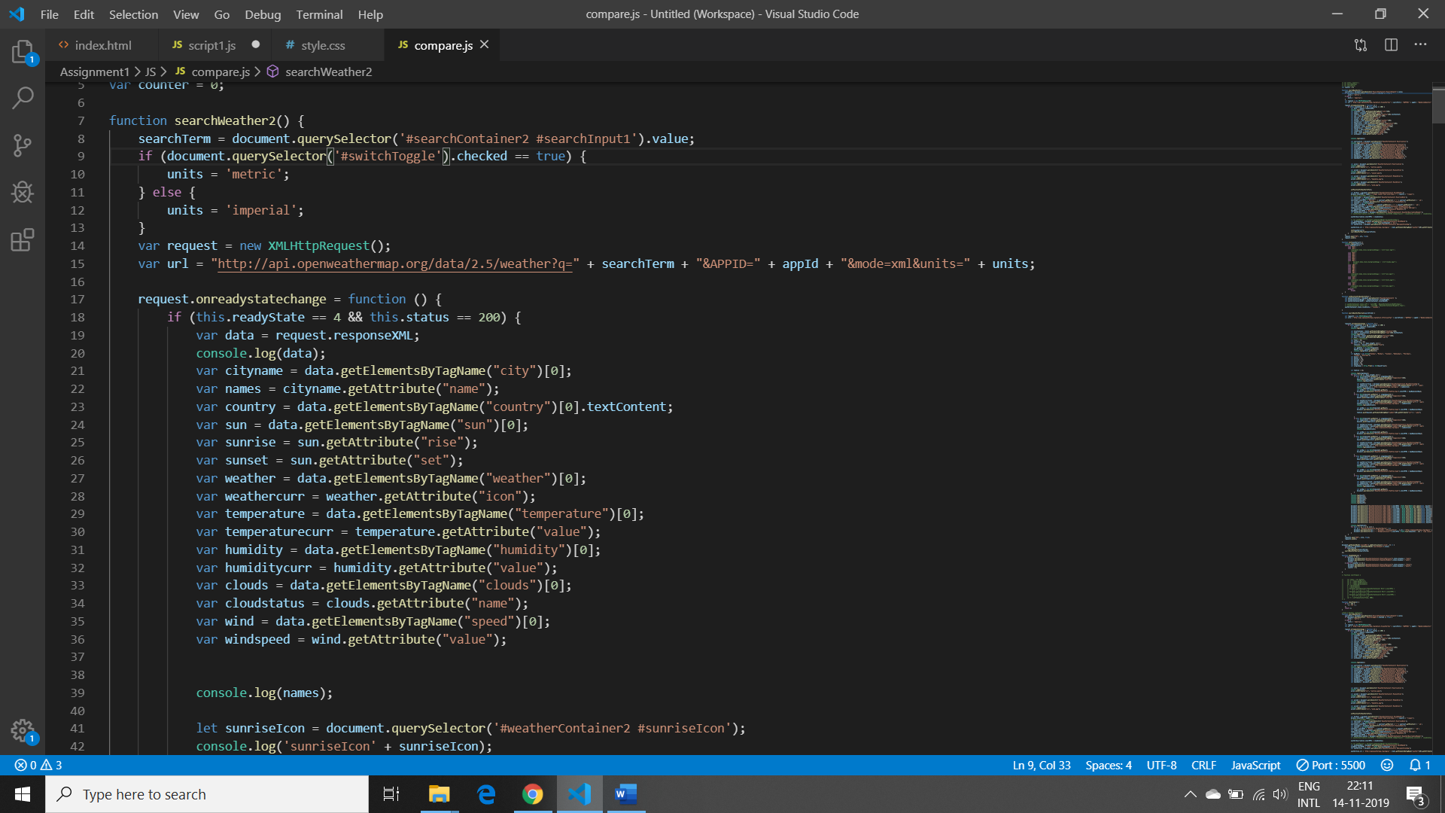

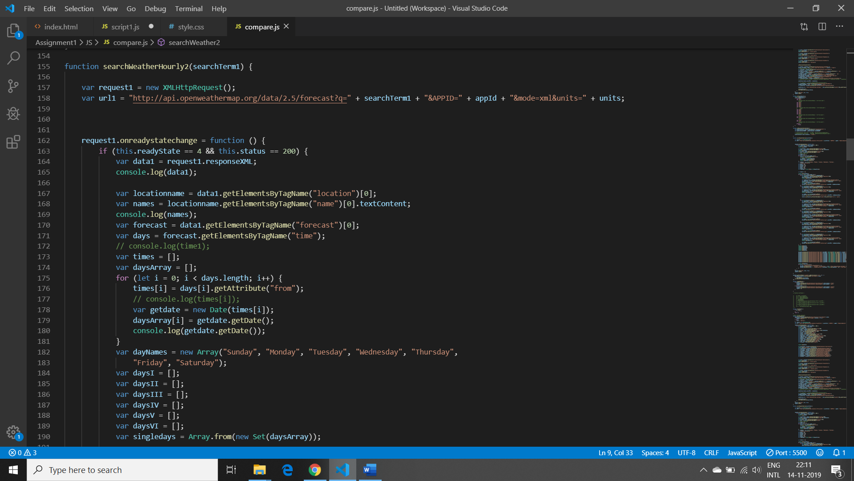

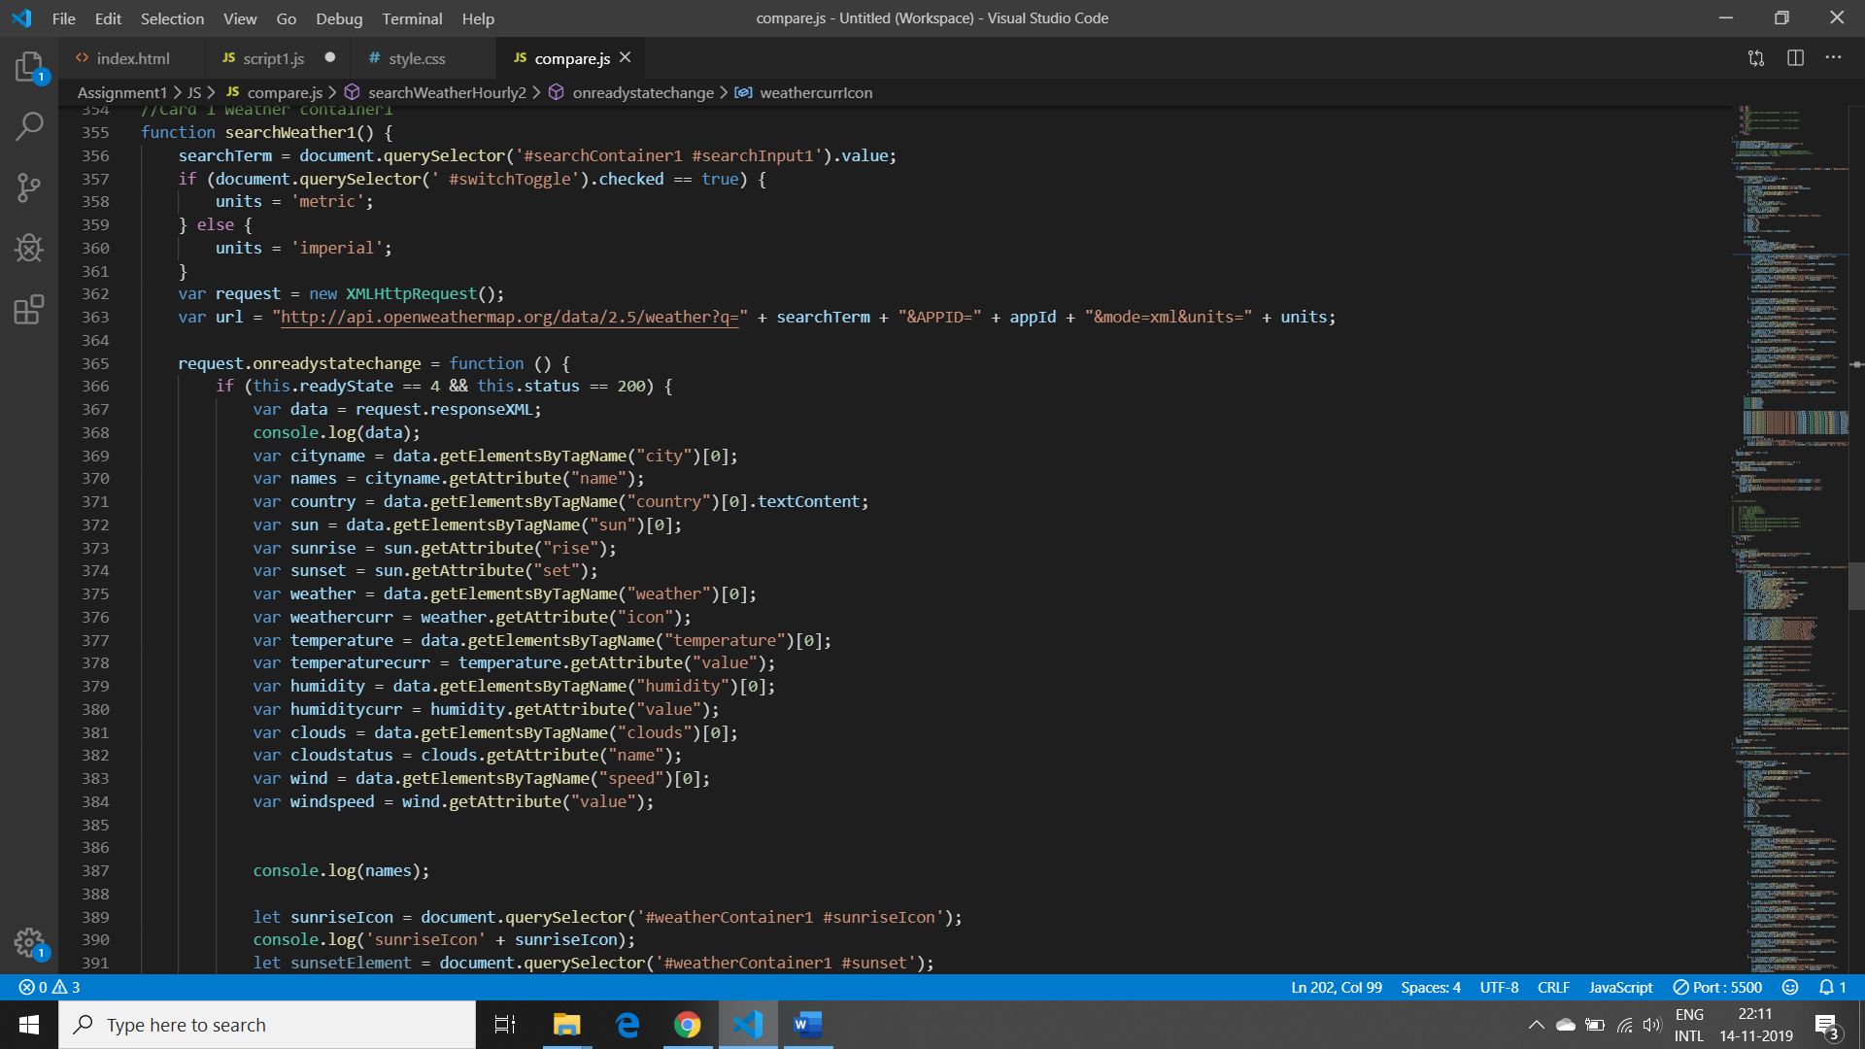

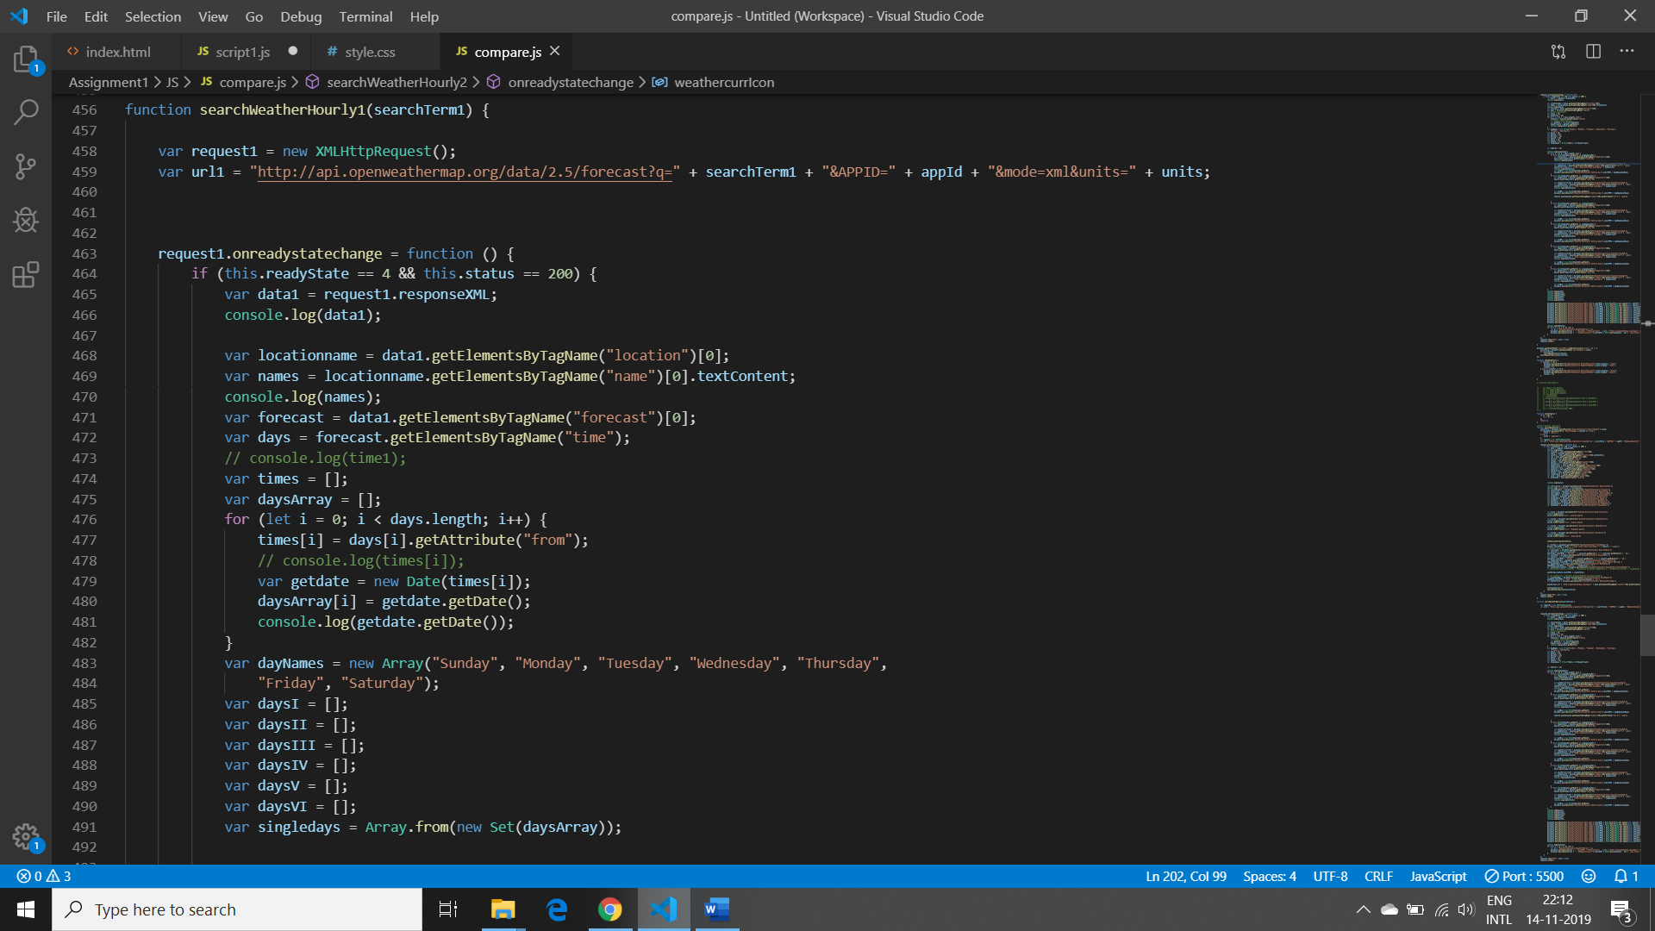

These are the 4 function for comparing cities.

## JS Code Snippet:

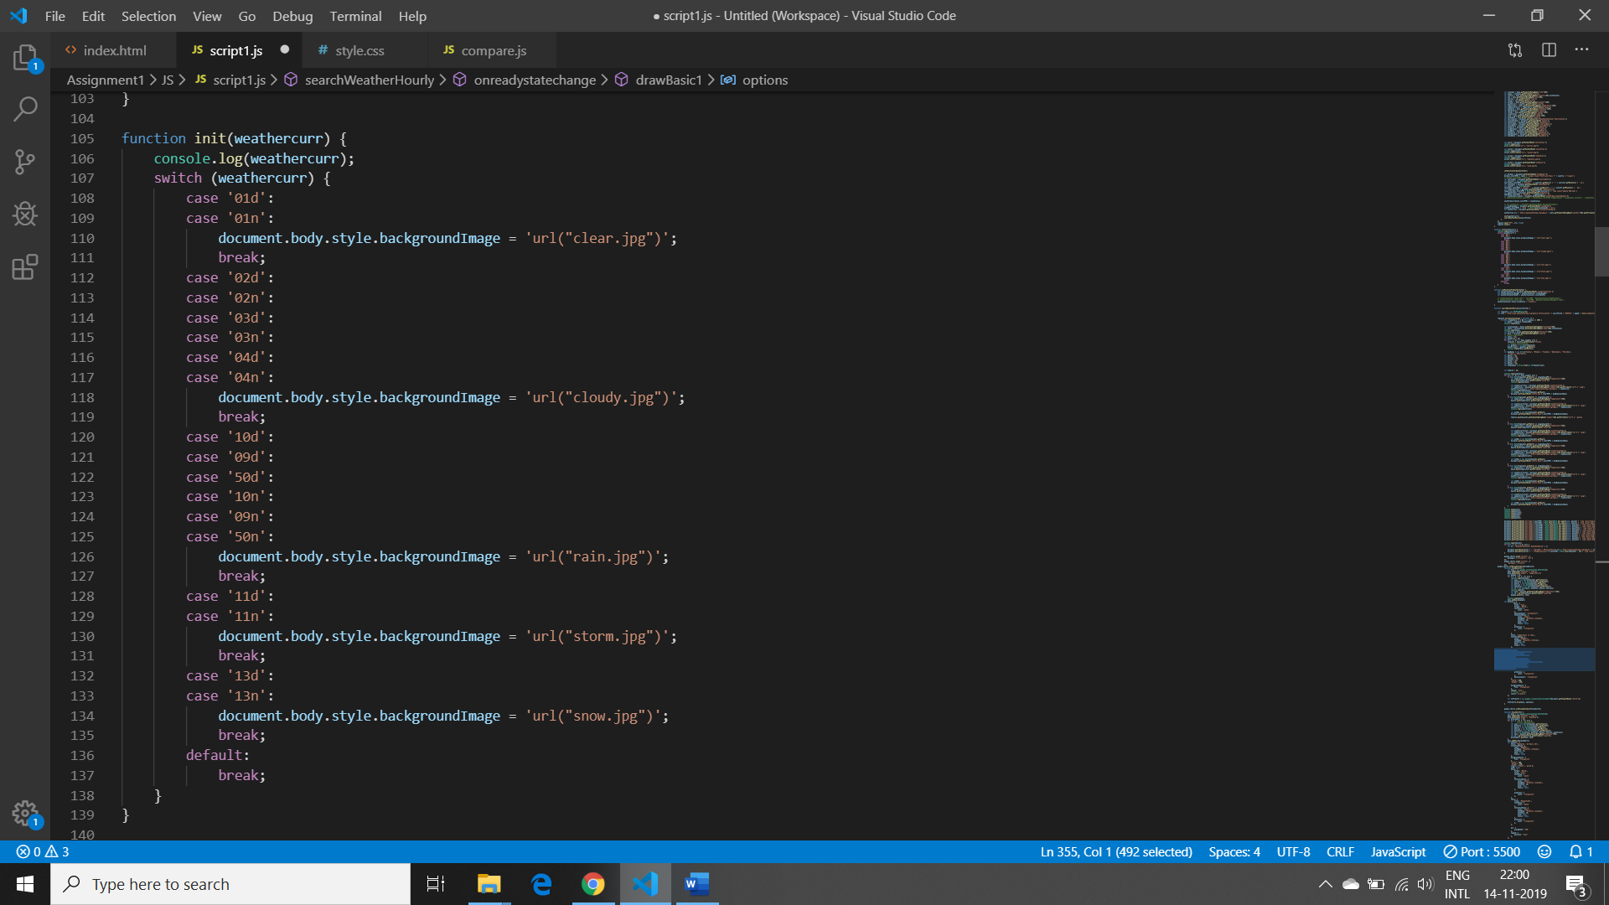

Here is the code for how background image changes according to the temperature.

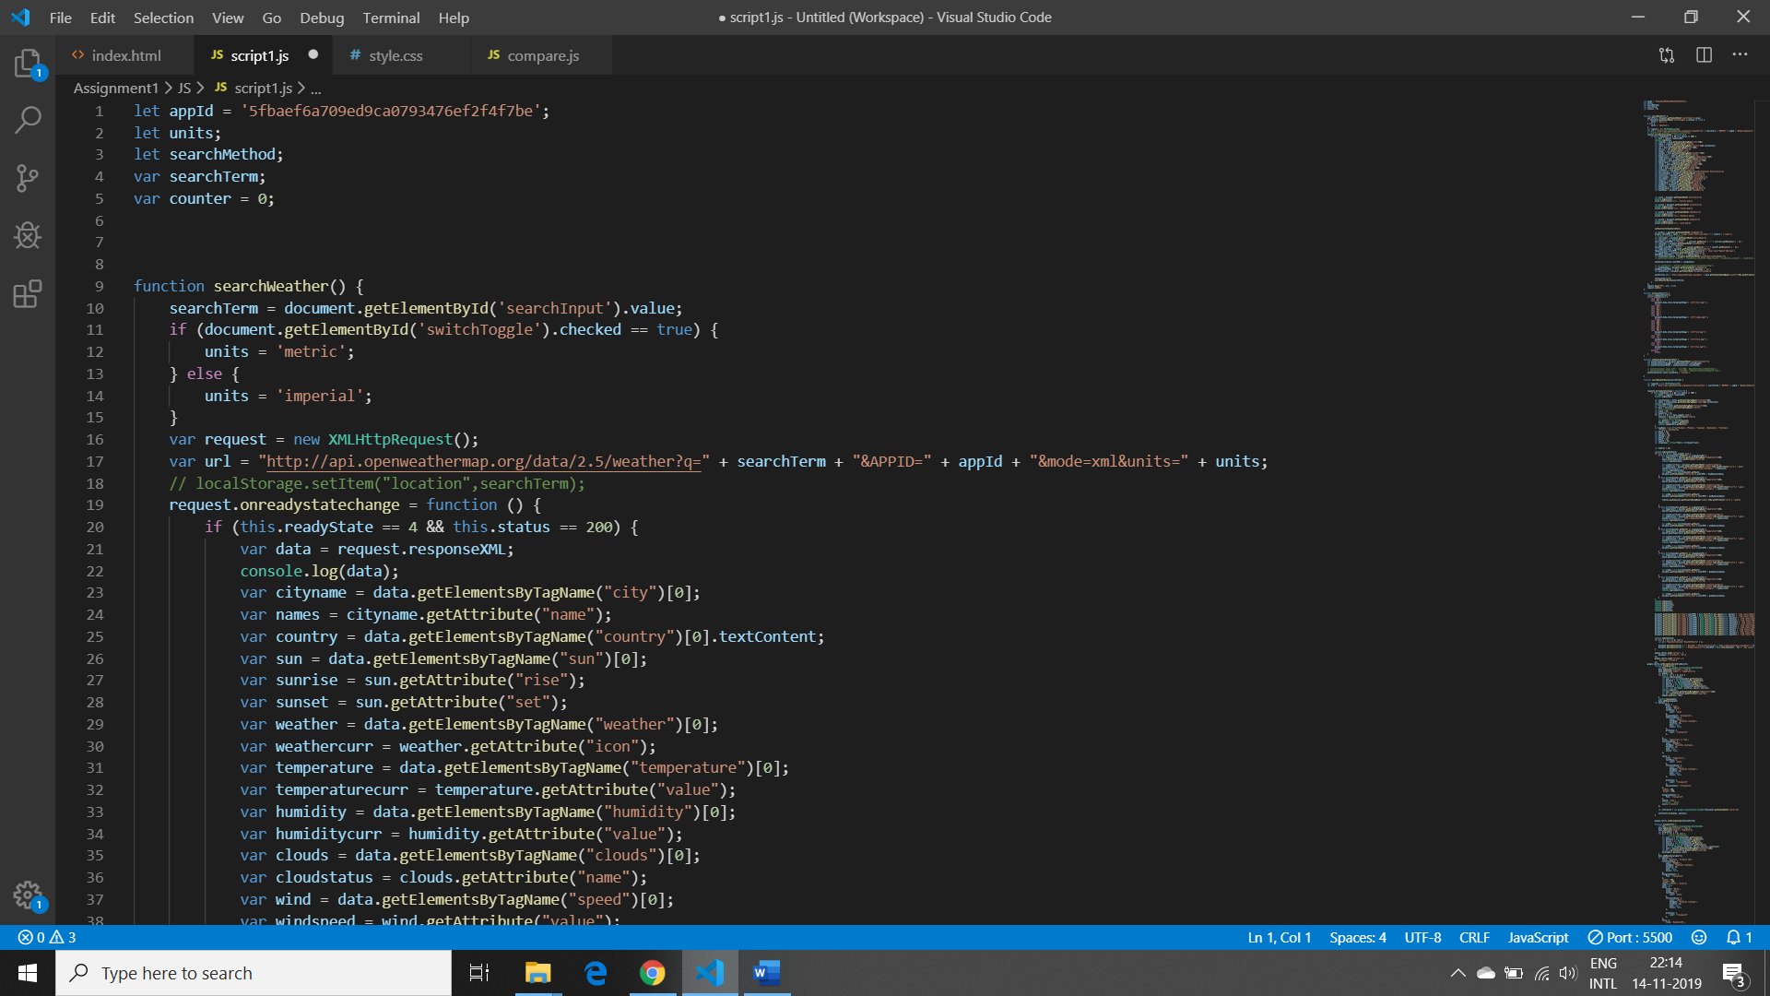

Here is the code, when I’m changing the degress from C to F. For this I’m putting the Units ,i.e. Metric and Imperial into the if confidition.

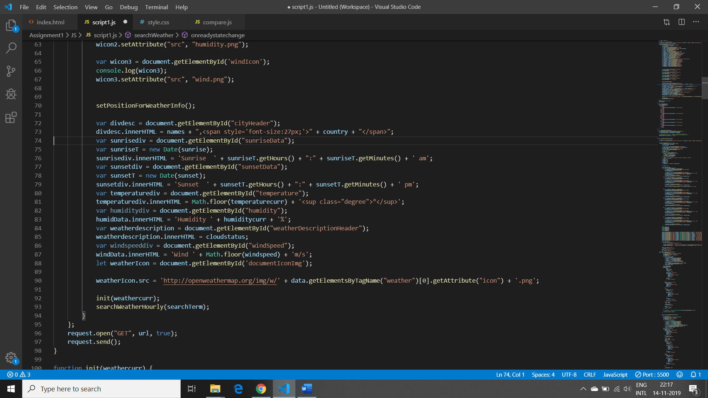

This is how I’m setting the icons for Humidity,Sunrise,Sunset,Wind and temperature.

## CSS Code Snippet:

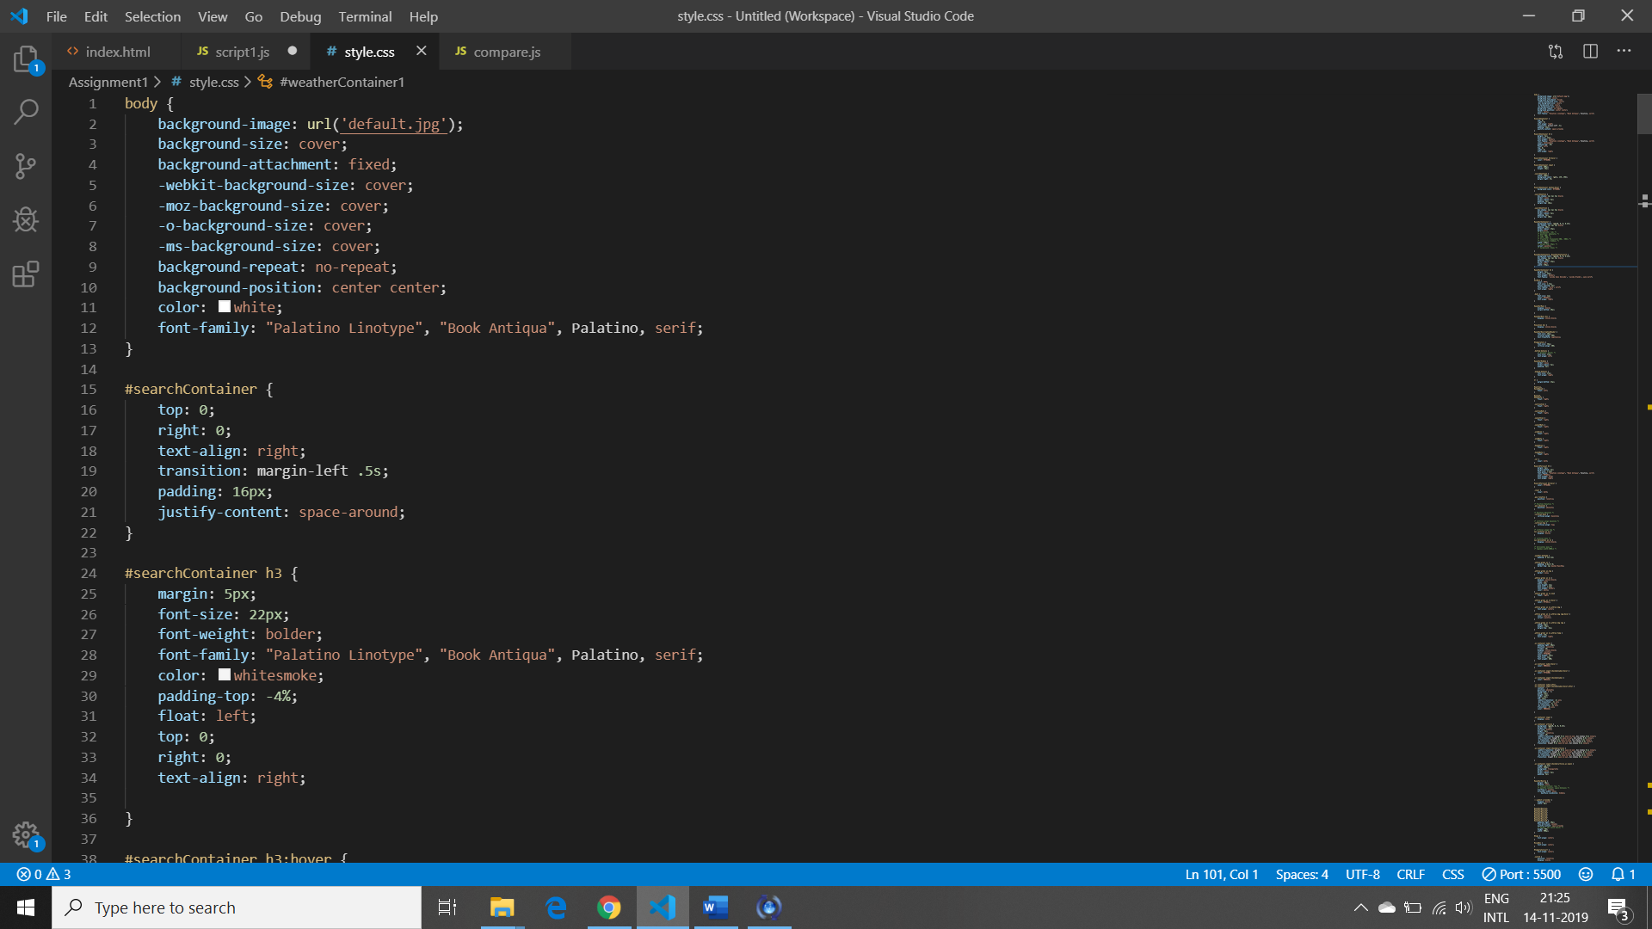 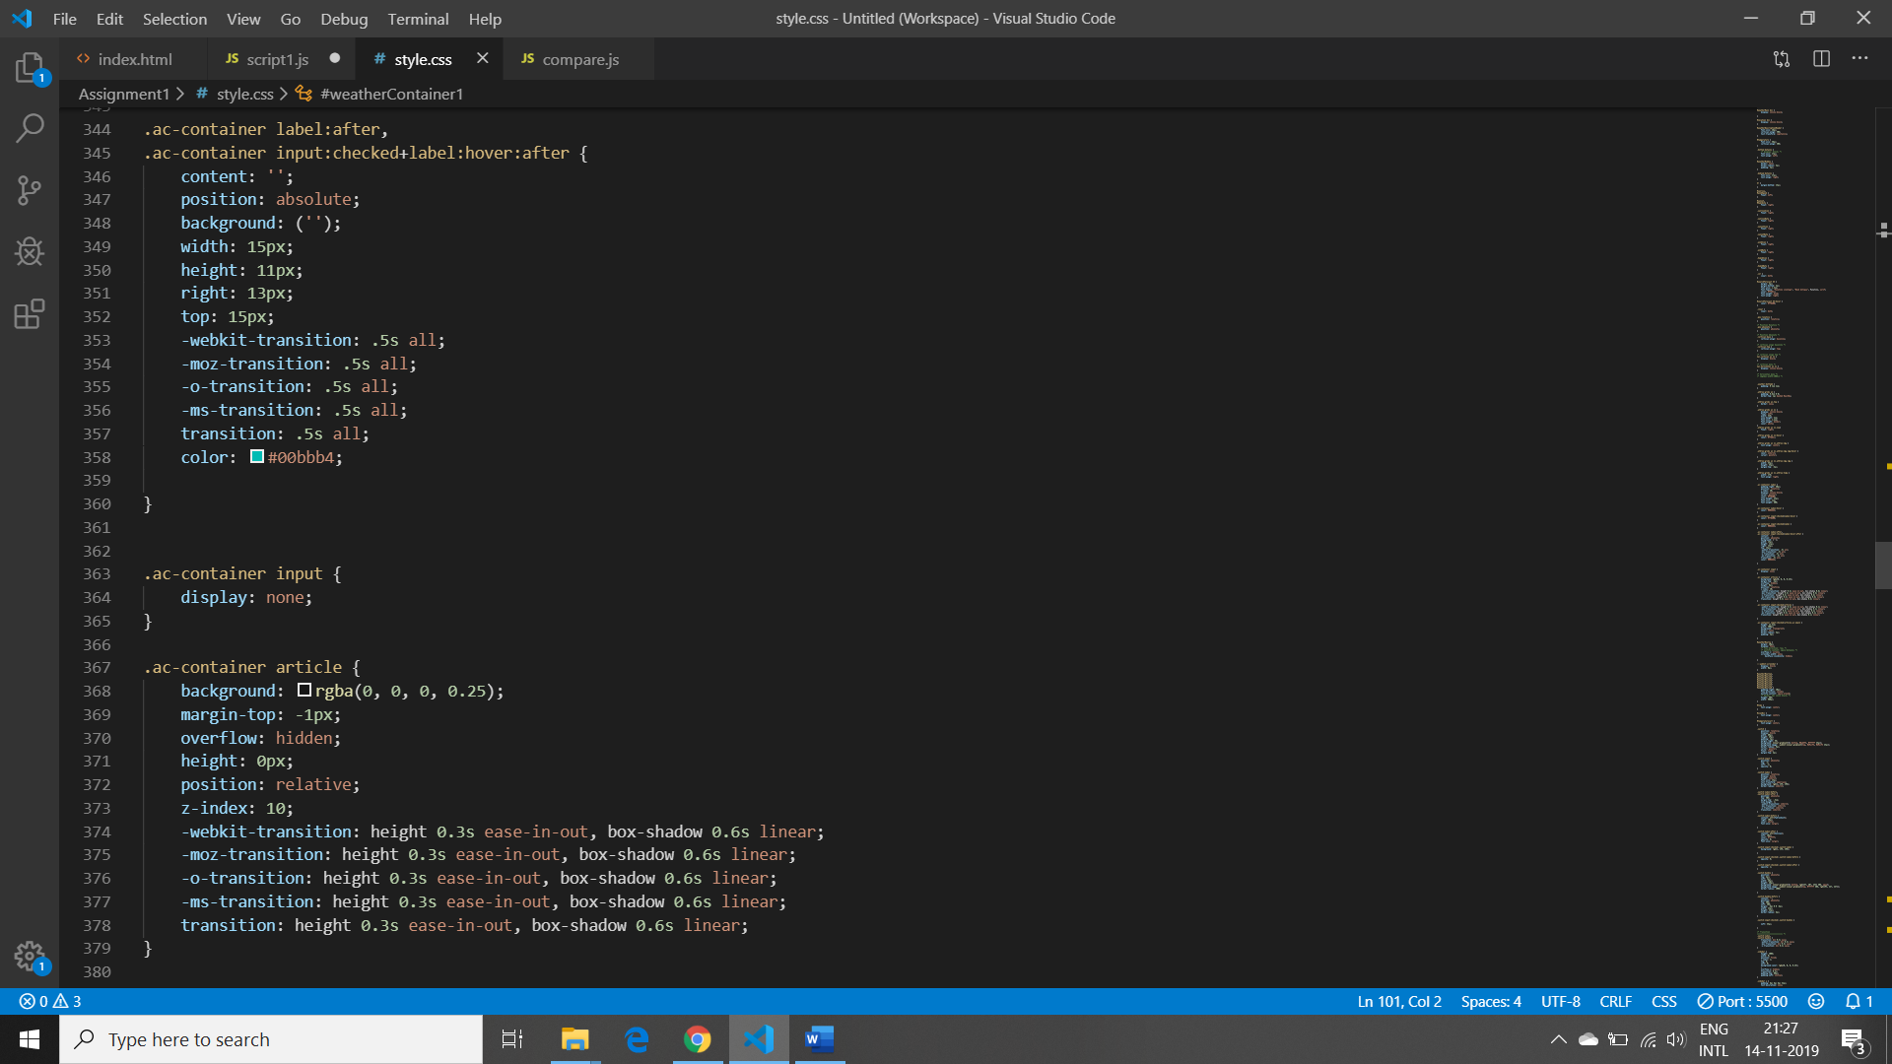 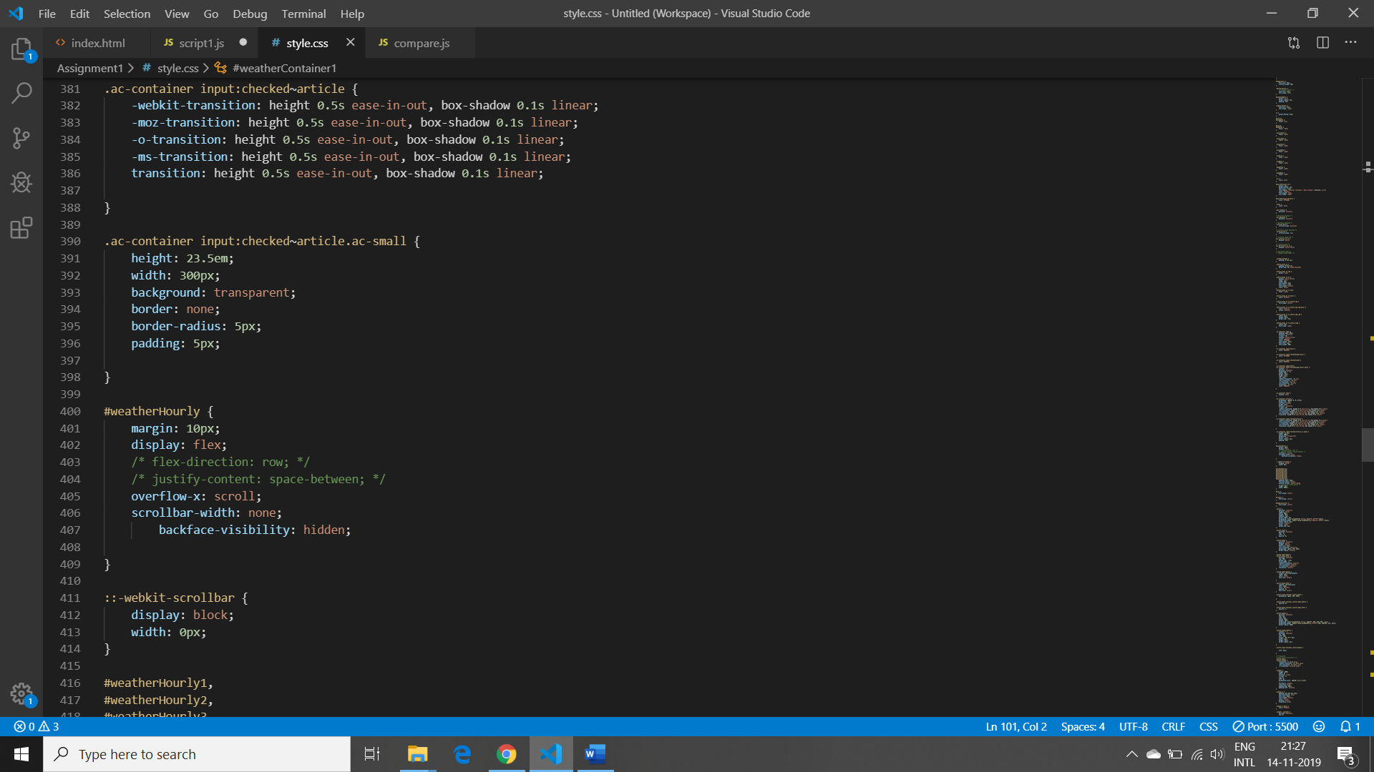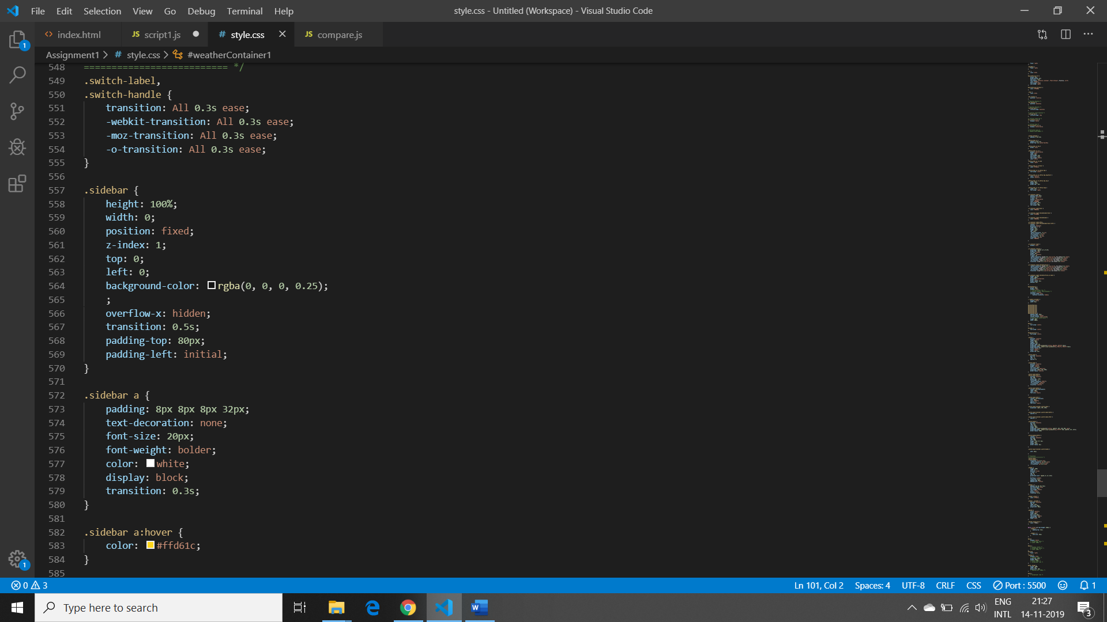

## Final Outputs:

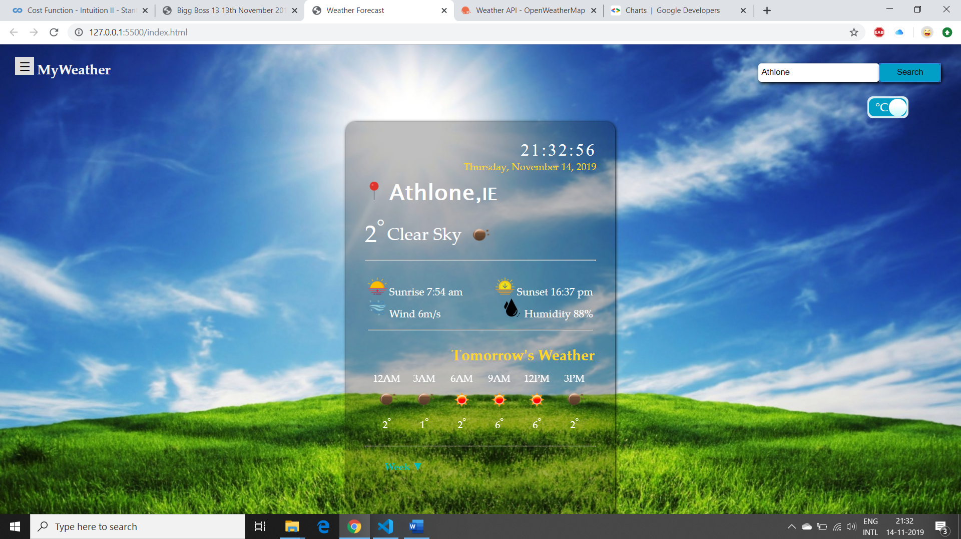

This is the main page of the application. By default, I have set city name as Athlone. In this main page, it has many features like:

* It changes the background image automatically according to the temperature of the city. For that I have used OpenWeather Icon URL and I have put the icons number in switch case so according to the number background image changes automatically.
* It shows the current Date Day and Time and Time gets updated automatically after every seconds.
* In the last div, It shows the tomorrow’s temperature with icons in 3 hours’ time interval. I have put that in horizontal scroll bar.
* In the top right hand side, there is a toggle button of C and F, so when you’ll click on that the temperature automatically gets updated according to Celsius and Fahrenheit degrees.
* At the bottom left hand side, hide and collapse button. When you’ll click on the dropdown symbol of ‘Week’, It will show the 5 days of min max temperature with icon. I have used grid layout to set the value in it.
* At the top, there is a navigation bar in that There are three tabs which is ‘Home’,’Charts’ & ’Comparison’.

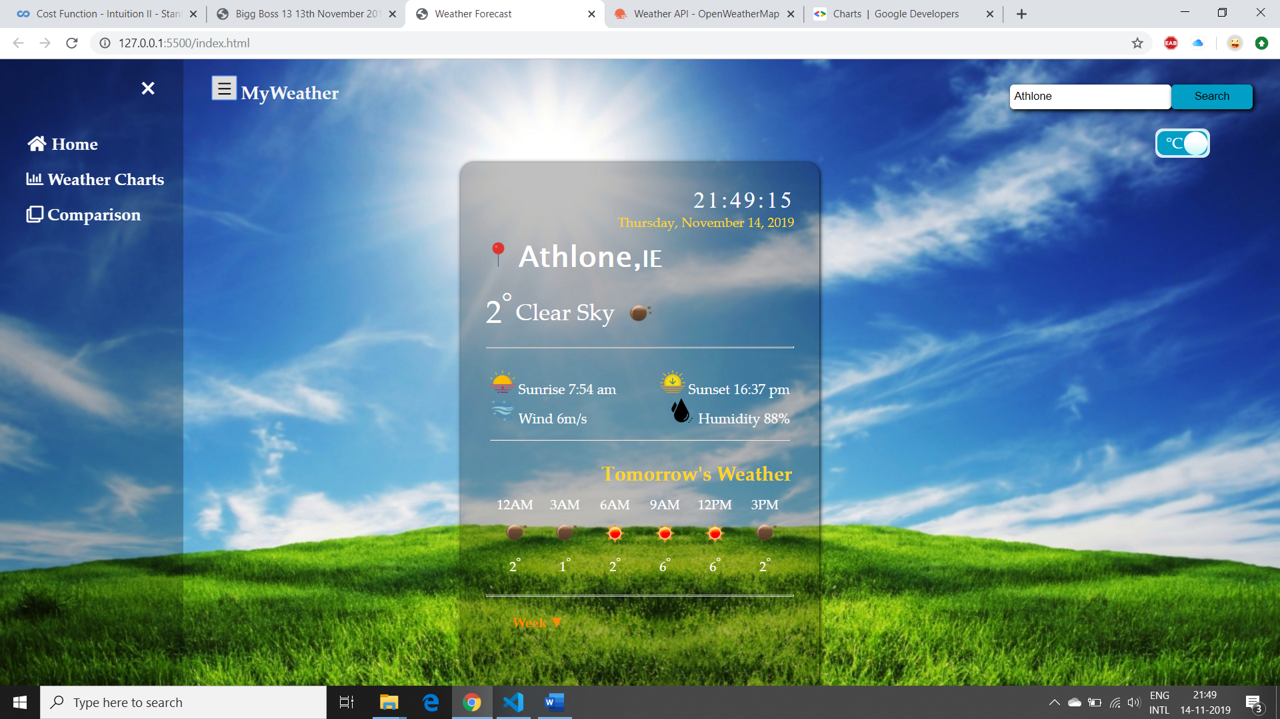

This is the navigation bar.

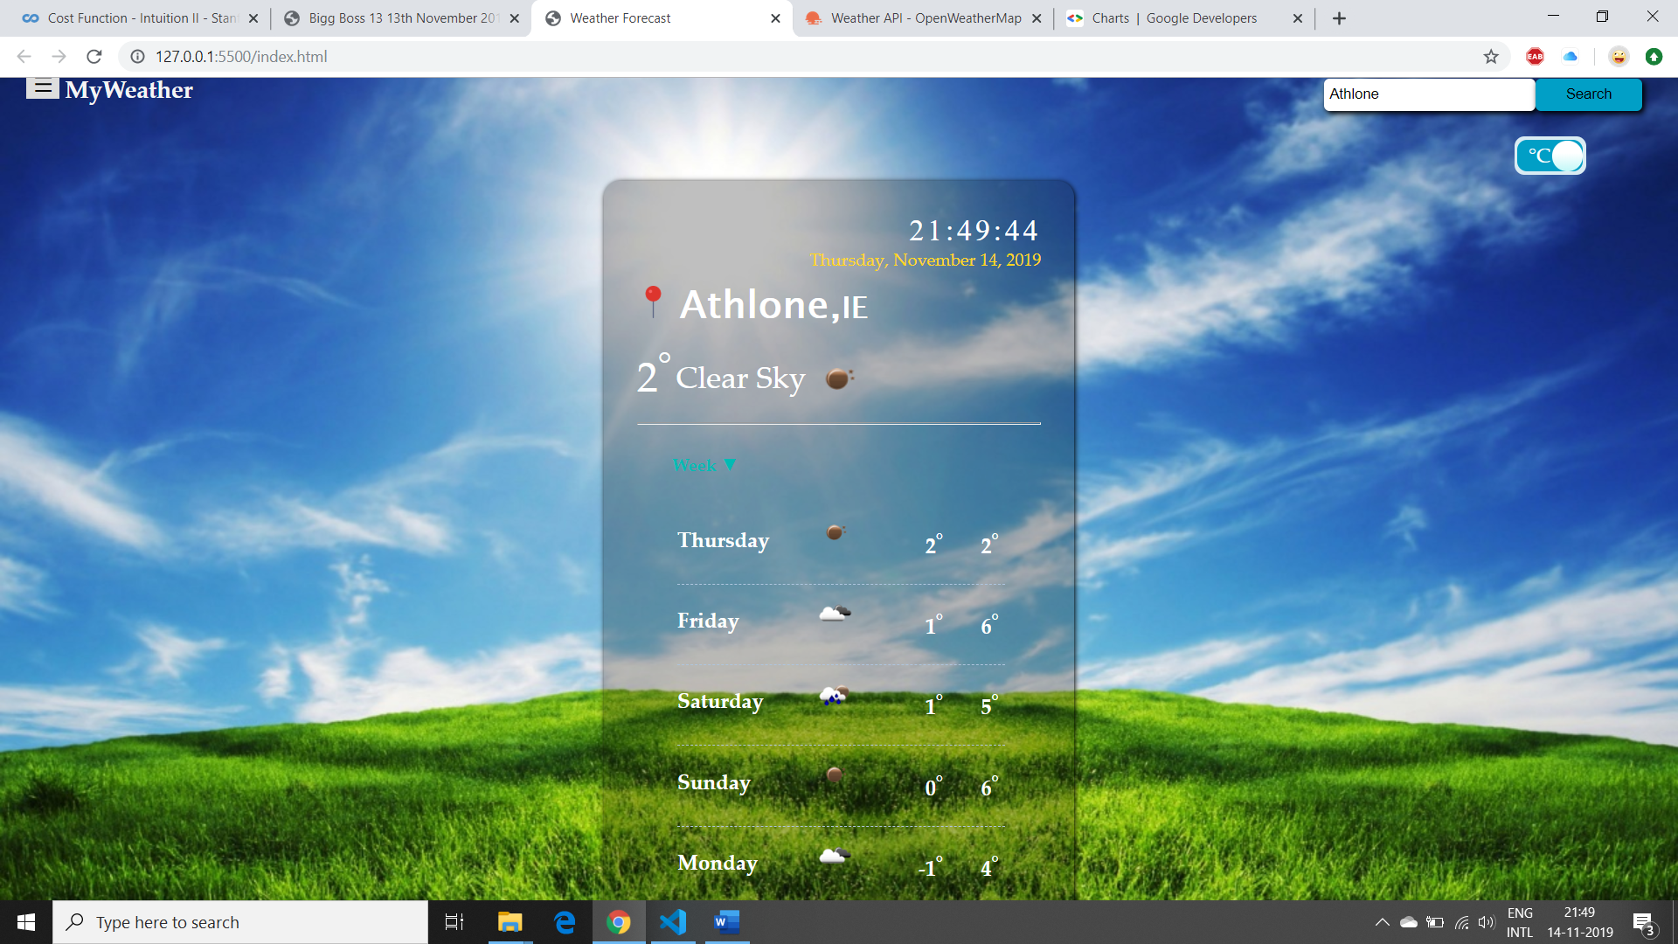

This is the 5 days Min Max temperature value, when I clicked on the drop-down button, so it hides the tomorrow’s weather data and then took place of that div.

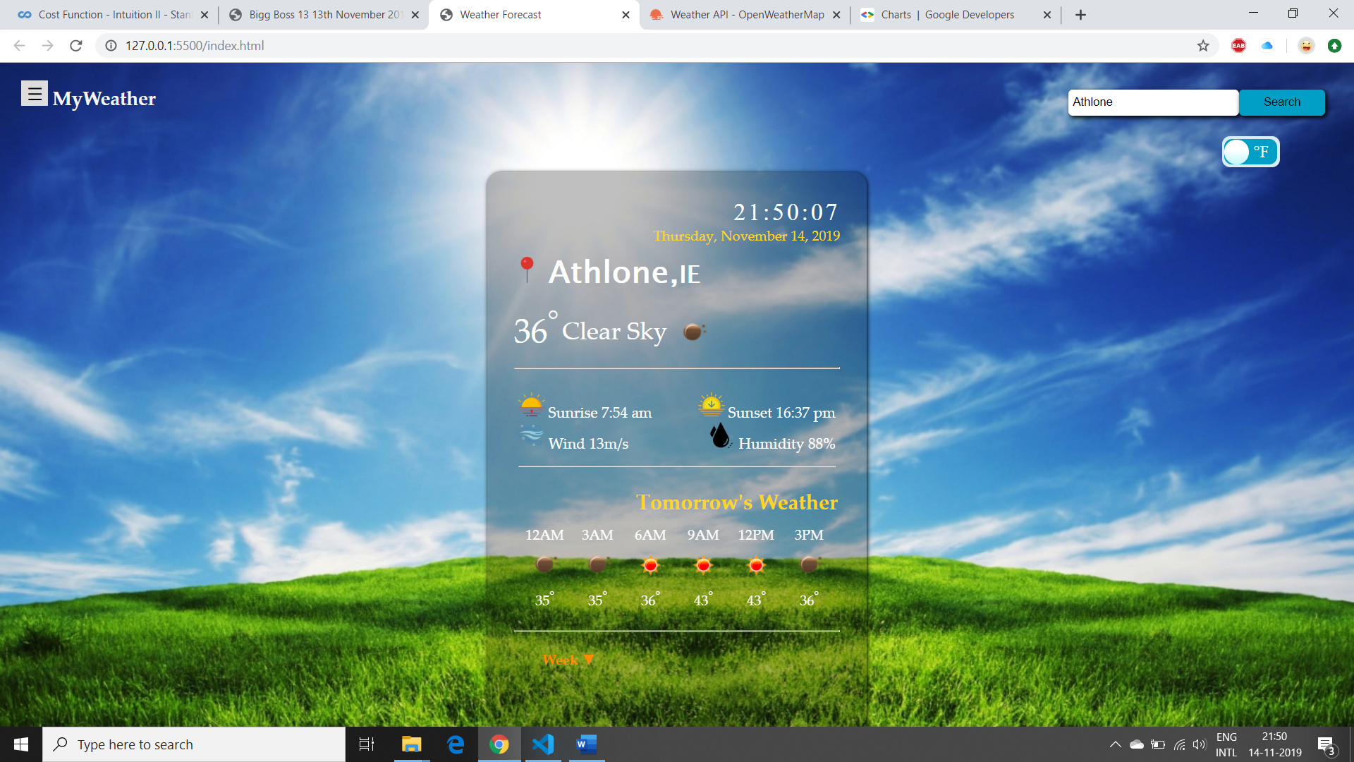

When I clicked on toggle button then it shows the value of degree in Fahrenheit.

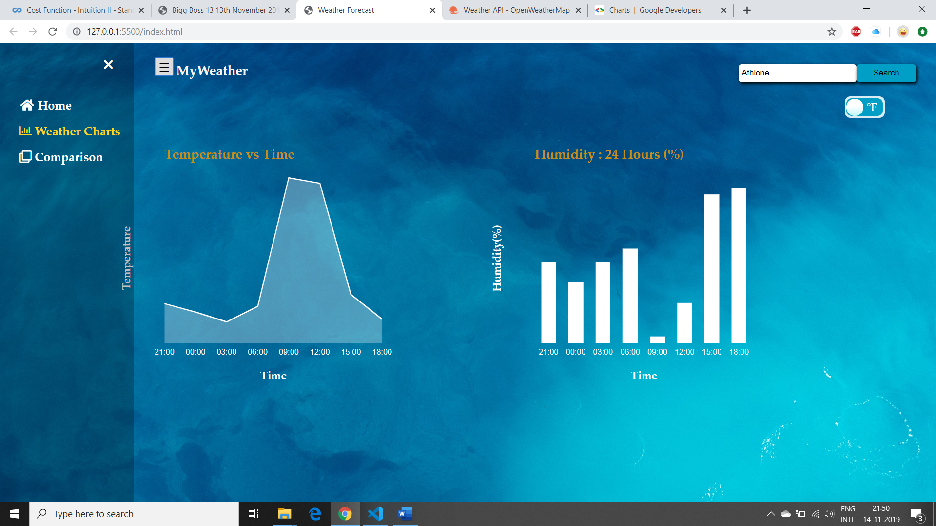

This page shows the bar charts and the line charts. Line Chart shows the Temperature of current day at 3 hours interval and Bar Chart shows the humidity of 24 hours at 3 hours of interval.

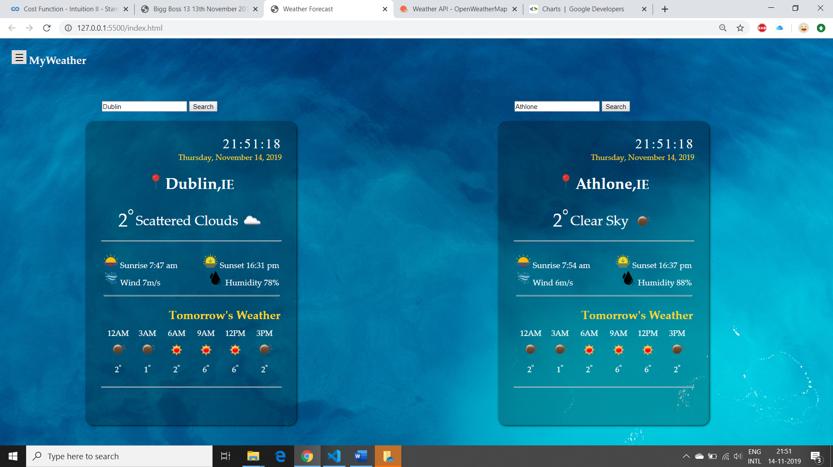

This is the compare city page.

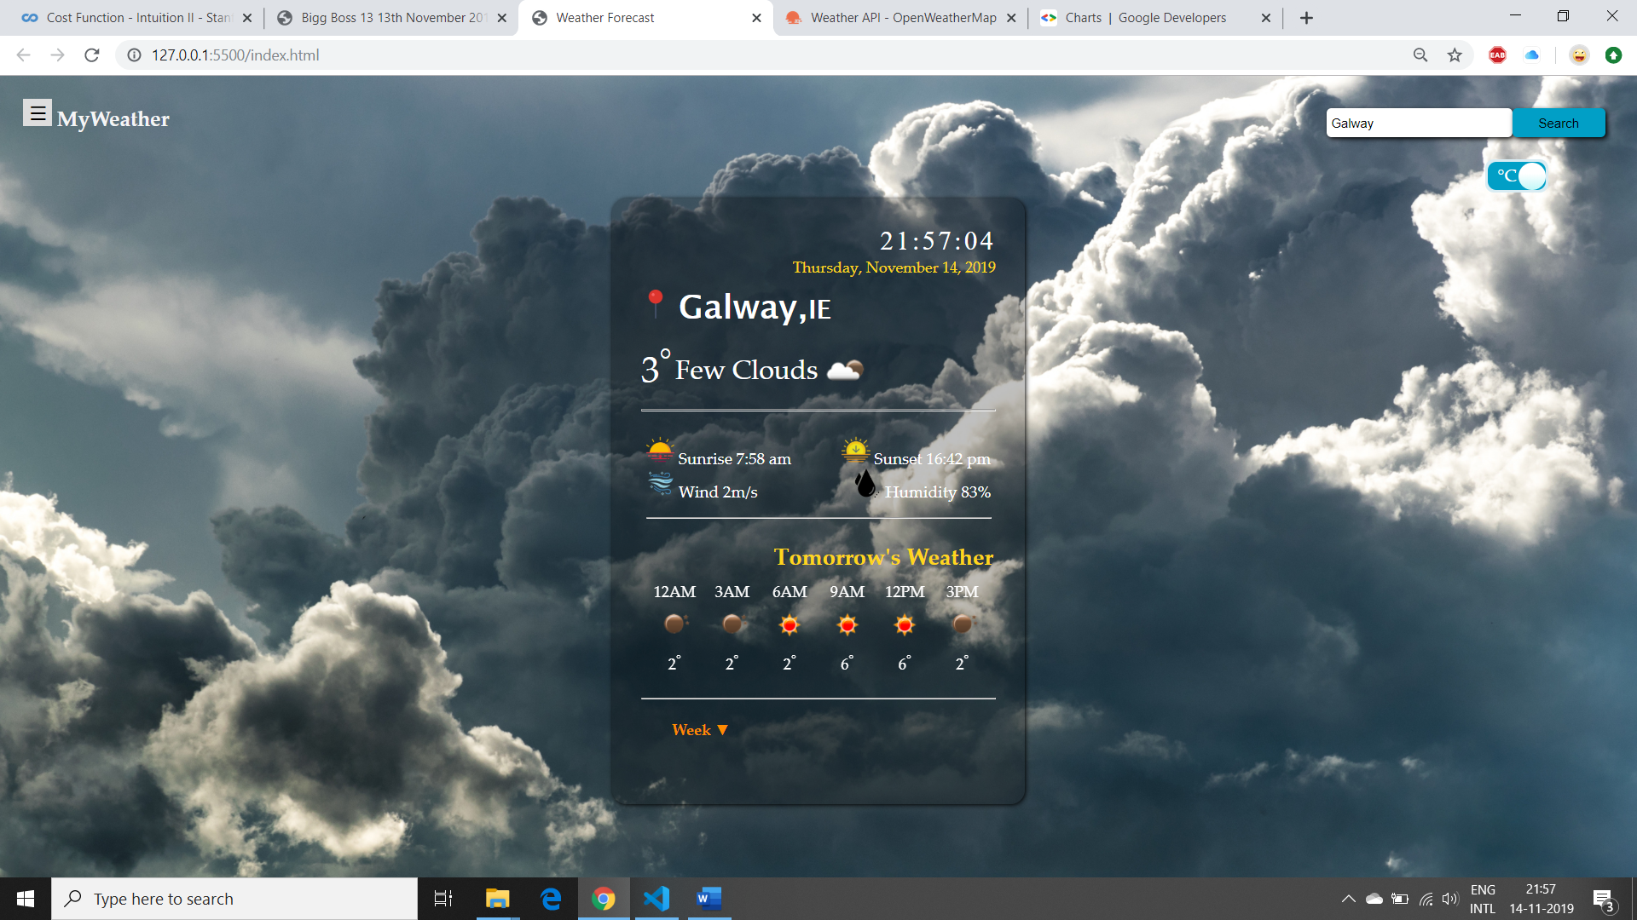

This is how background image changes according to the temperature.